Handout 3.7: Private Stress Map
Name: ______________________________ Date: ______________ Period: ______
Directions: Parts 1 through 4 stay with you. They go in your FACS folder, and nobody reads them unless you choose. I will look only to see that the grids are shaded and the stressors are tagged. I will not read what you wrote. The exit strip at the bottom is the only part you tear off and turn in. It asks for categories and roles, never for what the stress is. If anything on this page makes you want to talk to someone, the list of people is in Part 4 and on the back.

Word bank in Spanish
English | Spanish
stress | estrés
body | cuerpo
signal (a sign) | señal
help | ayuda
adult | adulto

Part 1: What stress is
Stress means: _______________________________________________________________________________
 | Good stress | Bad stress
How long | short | too long
Pointed at | something you can do | something too big or out of your control
What it does | sharpens you, then leaves | wears you down, does not leave on its own
One example from the slide
The alarm rule: the same alarm goes off for toast and for fire. Both times it is doing its job.

Part 2: Body signals
On the body outline, mark the places where stress shows up for you. Circle the place where it shows up first.
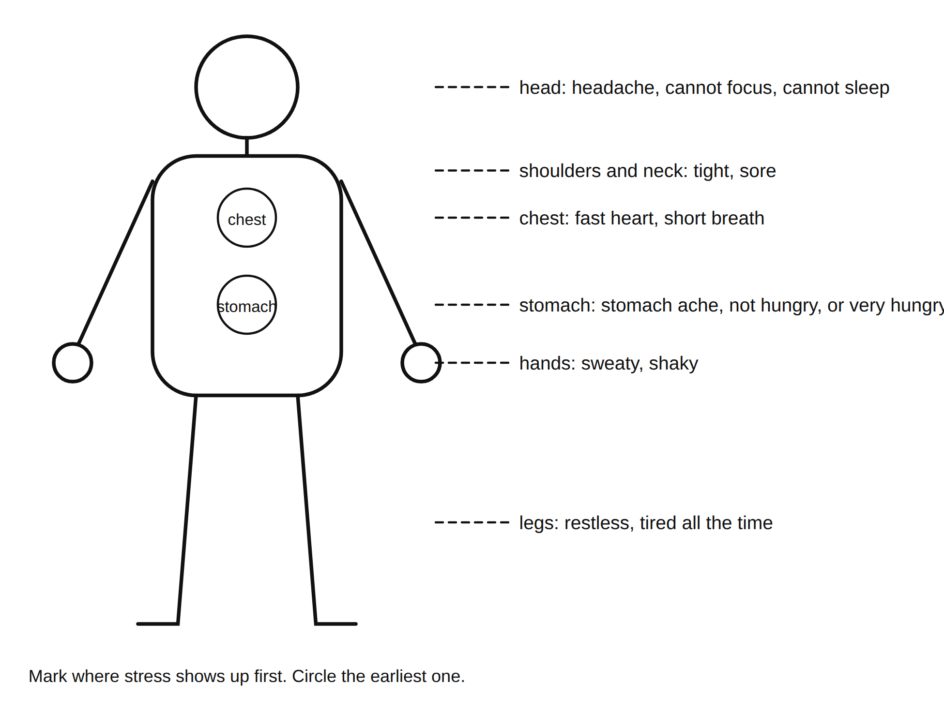
A body outline with the places stress shows up first
Signals from the board (copy six): _________________________________________________________________
(more) ____________________________________________________________________________________________
Signals that show in how you act (circle any): snapping at people / going quiet / cannot sit still / putting things off
My earliest signal: ______________________________________________________________________________

Part 3: The stress map (private)
When. Shade the boxes where stress shows up most. Light for a little, dark for a lot. Leave it blank if none.
 | Mon | Tue | Wed | Thu | Fri | Sat | Sun
Before school
During school
After school
Evening
Late night
Where. Shade the same way.
Home | School | Bus or travel | Phone | Practice or activity | Other: ______
Grade 6: fill the “when” grid only.
My stressors. A stressor is a thing that causes you stress. List yours here (a few words each). Tag each one with a category letter: S school (a book), F friends (two people), H home and family (a house), P phones and online (a phone), M money (a coin).
Stressor (a few words) | Category letter
Star the biggest one.
Grade 8 stretch: look at the map for a pattern (the same time every week, or the same place). Write two sentences: what could change the pattern, not the feeling?
Line 1: ____________________________________________________________________________________________
Line 2: ____________________________________________________________________________________________

Part 4: Handle it or bring it
The kind you handle yourself with a tool (tomorrow’s lesson): a test, a game, a busy week, an argument that will blow over, a Sunday night.
The kind you bring to an adult: anything that lasts for weeks; anything about safety; anything that makes you not want to be here; a friend who says any of those; anything you are not sure about.
My starred stressor is (circle): handle it / bring it
Who to ask (copy from the slide onto the back of this page too):
Person (a role) | Where or how
The school counselor
The nurse
Any teacher, including me
The main office
An adult at home
A help line the school approves

Exit strip (tear off; turn in)
Name: ______________________________ Period: ______
3 body signals of stress: __________________________________________________________________________
2 categories of stress most common for people my age (S, F, H, P, M): ______ ______
1 adult (a role, not a name) I would bring the big kind to, and why: _________________________________________
My starred stressor is in category ______ and is (circle): handle it / bring it
Grade 6: circle the categories: S F H P M

